CIT 447/547 – IPv4 OSPF Routing Lab

# Overview

We have been asked to design and implement both an IPv4 network using OSPF at ACME Inc. The specifications are shown the information on the network is shown in the topology below.

Here is a description of the network topology.
In the topology there are three IOU routers 
R1 is connected to PC1 via e1/0 and SW1 via e0/0.
R2 is connected to PC2 via e1/0 and SW1 via e0/1
R3 is connected to PC3 via e1/0 and SW1 via e0/2
R4 is connected to PC4 via e/0/0 and SW1 via e1/0
R4 is connected to R5 via s2/0 and R6 via s2/1
SW1 is connected to R1 via e0/0, R2 via e0/1, R3 via e0/2 and R4 via e1/0
R5 is connected to R4 via s2/0 and PC5 via e1/0 and R7 via s2/1.
R6 is connected to R4 via s2/1 and PC6 via e1/0 and R7 via s2/2.
R7 is connected to R5 via s2/1 and R6 via s2/2 and PC7 via e0/1
All the PC’s are connected to their respective routers via e0 interface on the PC


|  |  |  |  |
| --- | --- | --- | --- |
| **Area** | **Number of IPv4 Hosts** | **Number of IPv6 Hosts** | **Notes** |
| R1/PC1 | 1558 | 2077 |  |
| R2/PC2 | 1054 | 468 |  |
| R3/PC3 | 216 | 173 |  |
| R4/PC4 | 1209 | 437 |  |
| R5/PC5 | 451 | 349 |  |
| R6/PC6 | 245 | 567 |  |
| R7/PC7 | 111 | 44 |  |

Pay close attention to the specified IPv4 networks for the broadcast domain, including SW1 and connecting R1, R2, R3, and R4.

The internal IPv4 Subnet is 172.16.0.0/16, unless otherwise specified.

IPv4 OSPF Area: 15

Authentication: None

# Tools and Materials:

1. GNS3 Simulator
2. The base topology for this lab from Canvas.

# Steps

1. Download the starter topology from Canvas
2. Create your IPv4 addressing scheme for the network. Don’t forget that the serial links will need to be a separate Subnet. Give some thought to your subnetting for the serial links, so there aren’t many wasted addresses. A serial link, since it is point to point, only needs two host addresses.
   1. Assign the interface on the router connected to the VPCS the 1st IPv4 address of the subnet/prefix and assign the last IPv4 address of the subnet/prefix to the interface of the VPC.
   2. **Other than the serial links, don’t allocate less than a /24 (IPv4) subnet to any router – VPCS network.**

Complete the following table with your IPv4 network design. **(15 points)**

|  |  |  |  |  |
| --- | --- | --- | --- | --- |
| Description | Network Address | Subnet in CIDR (/XX) | Router IPv4 Address | VPCS IPv4 Address |
| R1 – VPCS1 |  |  |  |  |
| R2 – VPCS2 |  |  |  |  |
| R3 – VPCS3 |  |  |  |  |
| R4 – VPCS4 |  |  |  |  |
| R5 – VPCS5 |  |  |  |  |
| R6 – VPCS6 |  |  |  |  |
| R7 – VPCS7 |  |  |  |  |
| R1, R2, R3, R4, SW1 | 192.168.1.0 | /24 | R1: 192.168.1.1  R2: 192.168.1.2  R3: 192.168.1.3  R4: 192.168.1.4 | N/A |
| R4 – R5 |  | /30 | R4: 172.16.30.1 R5: 172.16.30.2 | N/A |
| R4 – R6 |  | /30 | R4: 172.16.30.5  R6: 172.16.30.6 | N/A |
| R5 – R7 |  | /30 | R5: 172.16.30.9  R7: 172.16.30.10 | N/A |
| R6 – R7 |  | /30 | R6: 172.16.30.13 R7: 172.16.30.14 | N/A |

1. Configure the IPv4 addresses per your design.

Some helpful commands for configuring IPv4 addresses.

int e0/0  
ip address 172.16.16.5 255.255.255.0  
no shutdown

Some helpful commands for configuring IPv4 addresses on the VPCS.

ip 172.16.16.254 255.255.255.0 172.16.16.1 <- The last address is the gateway. It should be the ip address of the router

**NOTES:**

1. **In the topology all the routers interfaces connected via switch SW1 are in the same broadcast domain (i.e., network).**
2. **All the IPv4 addresses connecting to SW1 should be in the same Subnet.**
3. **There is no configuration needed on any of the switches.**
4. Verify that IPv4 network connectivity is working as expected using pings.
   1. The interfaces that at directly connected to each other should be able to ping each other regardless of whether or not routing is running. For example, PC1 should be able to ping the e1/0 interface on R1.
5. Implement IPv4 OSPF on each of the routers using area 15.

Some helpful commands for configuring IPv4 routing.

router ospf 1  
passive-interface e1/0  
network 192.168.1.1 0.0.0.255 area 15

A few things to keep in mind when configuring OSPF routing on IPv4.

1. The process number (e.g., router OSPF 1) only indicates which OSPF process we are configuring.
2. Remember that OSPF routing using wildcard masks, not subnet masks, when specifying the network it is routing.
3. Passive interfaces are only set up for interfaces that don’t have other routers connected. It tells the router to ignore any hello messages received on that interface. So it should only be set on interfaces connected to end-user devices, in this case, the VPCS.
4. Verify that you can ping across the network.
5. Answer the questions on the next page.

**Questions**

Questions 1 and 2 are the tables from the lab.

1. Complete the following table with your IPv4 network design. **(15 points)**

|  |  |  |  |  |
| --- | --- | --- | --- | --- |
| R1 – VPCS1 | 172.16.0.0 | /21 | 172.16.0.1 | 172.16.0.254 |
| R2 – VPCS2 | 172.16.8.0 | /21 | 172.16.8.1 | 172.16.8.254 |
| R3 – VPCS3 | 172.16.16.0 | /24 | 172.16.16.1 | 172.16.16.254 |
| R4 – VPCS4 | 172.16.17.0 | /21 | 172.16.17.1 | 172.16.17.254 |
| R5 – VPCS5 | 172.16.24.0 | /23 | 172.16.24.1 | 172.16.24.254 |
| R6 – VPCS6 | 172.16.26.0 | /24 | 172.16.26.1 | 172.16.26.254 |
| R7 – VPCS7 | 172.16.27.0 | /24 | 172.16.27.1 | 172.16.27.254 |
| R1, R2, R3, R4, SW1 | 192.168.1.0 | /24 | R1: 192.168.1.1  R2: 192.168.1.2  R3: 192.168.1.3  R4: 192.168.1.4 | N/A |
| R4 – R5 | 172.16.30.0 | /30 | R4: 172.16.30.1 R5: 172.16.30.2 | N/AS |
| R4 – R6 | 172.16.30.4 | /30 | R4: 172.16.30.5  R6: 172.16.30.6 | N/A |
| R5 – R7 | 172.16.30.8 | /30 | R5: 172.16.30.9  R7: 172.16.30.10 | N/A |
| R6 – R7 | 172.16.30.12 | /30 | R6: 172.16.30.13 R7: 172.16.30.14 | N/A |
| R1 – VPCS1 | 172.16.0.0 | /21 | 172.16.0.1 | 172.16.0.254 |

1. From PC1 ping using IPv4, the VPCS PC7 and PC4. This requires two pings. Paste the screenshots of the results. **(10 points each, 20 points total)**

PC1 to PC7:

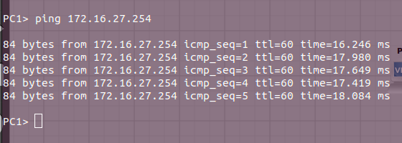

PC1 to PC4:

* 1. 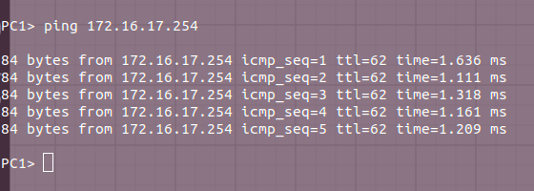Which router is the backup designated router (BDR) for ipv4? **(10 points)**
  2. **The next BDR is Router 4 (192.168.1.4)**

1. From R4 do a show ip route.
   1. What are the IPv4 routes to the network connected to e1/0 on R3? **(5 points)**
   2. **192.168.1.4, 192.168.1.0**
      1. How many possible routes are there? **(5 points)**
      2. **There are 16 different routes**
   3. What are the IPv4 routes to the network connected to e1/0 on R7? **(5 points)**
   4. **172.16.27.0/24**
      1. How many possible routes are there? **(5 points)**
      2. **There appear to be 6?**
2. In your configuration, which interfaces did you make passive? List the router and interfaces on that router. **(5 points)**
   1. **R1 e1/0**
   2. **R2 e1/0**
   3. **R3 e1/0**
   4. **R4 e0/0**
   5. **R5 e1/0**
   6. **R6 e1/0**
   7. **R7 e1/0**
   8. Why? **(5 points)**
      1. **I made them passive interfaces because they connect to the VPC end devices.**
3. From VPCS PC7 perform a traceroute to VPCS PC1

trace ipv4_addr

* 1. What path did it take? **(5 points)**

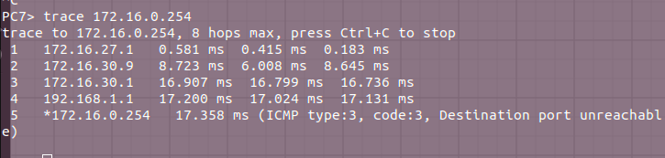

* 1. Is this the path expected? **(5 points) Yes**

1. List the OSPF neighbors on R4.
   1. IPv4 neighbors **(5 points)**

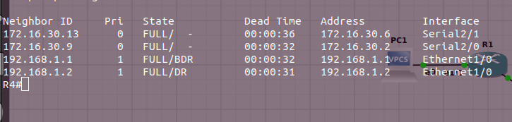

1. Save your configurations on each router (copy ru st). Export the completed project to a portable GNS3 project and upload it with your lab write-up. **(10 points)**
2. **Note: We will build on this lab next week by adding IPv6 to run in parallel with IPv4.**